Heritage Early Childhood Centre

The Australian National University
Canberra
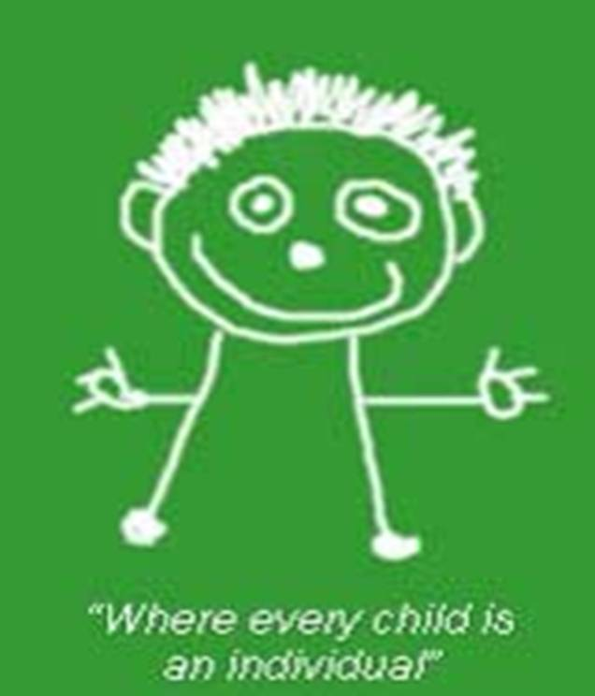

“Where every child is an individual”
Relief Educator Handbook 2022

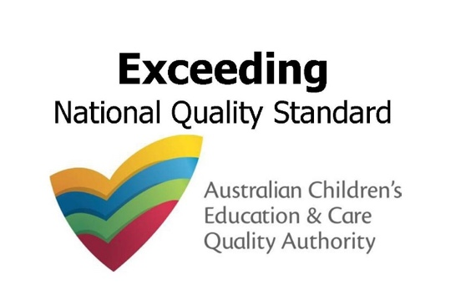

Address: 75 Lennox Crossing, The Australian National University, ACTON 2601
Ph: 02 6249 8851 Email: info@heritageecc.com.au
Website: heritageecc.com.au

Table of Contents
Introduction 4
The Heritage Philosophy 5
The Role of Relief Educators 7
Induction Procedures 7
Family Expectations 7
Employment Conditions 8
Hours of Work 8
Punctuality 8
Timesheets 8
Pay 8
Staff Amenities 8
Duties and Responsibilities 9
Attitude of Cooperation 9
The Model Relief Educator 9
Insubordination 10
Coarse Language 10
Relationships and Interactions with Children 10
Supporting Children’s Behaviour – Phoenix cups/Teachable Moment Strategies 10
Supervision of Children 12
Professional Relationships 13
Honesty and Integrity 13
Confidentiality 13
Authorisations 13
Staff Relationships 13
Relationships with Families 13
Relationships with Visitors 14
Social Media and Canvassing for Causes 14
Personal Telephone Calls 14
Health and Safety 15
Accidents, Illness and Emergencies 15
Smoking, Drugs and Alcohol 15
Standards of Dress/Footwear 16
Personal Hygiene 16
Handwashing 16
UV (Sun) Protection 17
Complaints, Grievances and Non-Compliance Policies 17
Child Protection Policy 17
Heritage Emergency Evacuation Floor Plan 19
Summary of COVID-19 Policy and Procedures as at May 2022 20
Heritage Privacy Statement 23
Heritage Code of Conduct/Ethics 24
Acknowledgement of Code of Conduct/Ethics and Agreement of Terms 26

Introduction

Heritage Early Childhood Centre (Heritage) is a small, community-based early education and care service which caters mainly for the children of staff and students at The Australian National University. To maintain its reputation for providing high quality and individualised early childhood education and care, Heritage needs the co-operation of dedicated education and care professionals to support the needs of each enrolled child.
At Heritage, we strive to create an environment which is happy, positive, caring and educational. We aim to build genuine partnerships between management, educators, families and children and to create a holistic curriculum which supports the wellbeing of each child, enabling them to reach their potential by acquiring the skills necessary for life and learning.
Every club, sports team or business must have some guiding principles or rules for its members, so they know what is expected of them. This Handbook is designed as a simple guide for you as a relief Heritage educator. It provides guidelines for you regarding Heritage policies and procedures, the conditions of your employment and other information so that you will clearly understand your professional education and care giving role and responsibilities.
Our guidelines have been thoroughly researched to reflect current best practice, common sense and simplicity to make educating and caring for children at Heritage a friendly and professional experience and to ensure a happy work place. When education and care professionals work together respectfully, with the best interests of the children and service in mind, the result is a motivated team and a pleasant atmosphere for all.
The Handbook is designed to cover most of the information you will need, but please do not be afraid to ask further questions of the Heritage Director.

WELCOME TO HERITAGE!
WE ARE VERY HAPPY TO HAVE YOU!

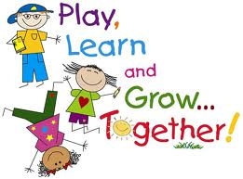
The Heritage Philosophy Statement
The Heritage Philosophy Statement is our written document which outlines the values, principles and practices that underpin our work and educational program. It is based on the Early Years Learning Framework (EYLF) and evolves according to the beliefs and values that are collectively held by Heritage educators and families. Please read the full statement below:

We recognise that teaching & learning have continued to take place on the land on which our Centre stands for many thousands of years. We are honoured to continue this tradition and acknowledge the Ngunawal people as the Traditional Custodians of the land.

Our Mission: Our mission is to work together to build a safe, respectful and nurturing environment focused on maximising each child’s sense of wellbeing and acquisition of skills for life and learning (Belonging, Being and Becoming).

Our Vision: Our vision is to create a warm and inclusive family atmosphere where all educators and families feel inspired to work together in a genuine partnership focused on providing a dynamic learning environment to ensure each child realises their full potential. Regardless of race, gender, age, ability, social status or family structure, our vision is to ensure each child is able to participate in all aspects of the program. We value the different gifts that each child brings to our community and embrace the many world cultures represented at Heritage. We celebrate our multicultural roots for the wealth of knowledge and understanding they bring to our community and Aboriginal and Torres Strait Islander cultures, identities and connections to community and country are valued.

Our Vision for Reconciliation is to look forward to a day when all Australians celebrate the longstanding and continuing contributions of the First Australians to our nation's shared history and identity. It is important that we, as a country, recognise our true history and the diverse past, present and continuing cultures and contributions of Aboriginal and Torres Strait Islander peoples. We strive to ensure that we continue to respectfully embed Aboriginal and Torres Strait Islander cultures in all that we do. We acknowledge that it is a child’s right to learn about the Ngunawal Land and the Traditional Custodians and their histories and are committed to reaching out to Aboriginal and Torres Strait Islanders people within our community to break down barriers and move forward together. As early childhood educators, we understand that ‘from little things big things grow’ and that a child's learning journey and reconciliation journey begins here.

Our Aims
Respect and Dignity: We aim to ensure each child is given the opportunity to play, discover and grow in an atmosphere of care and mutual respect where their dignity and rights are preserved at all times.

Emotional Security: We aim to build warm, respectful and meaningful relationships between all our children, families and educators in order to create a community of learners which is a support network for all. We know that respect comes from being acknowledged, understood and empathised with in relationships that have meaning, and understand the importance of establishing an emotionally secure foundation based on respect in order to support each child’s developing sense of self and empathy for others.

Our Philosophy
Holistic and Inclusive Approach: We take a holistic and inclusive approach to caring for and educating our children and aim to develop each child’s understanding of the world in which they live by developing broad based knowledge, skills and attitudes to prepare them for lifelong learning. We aim to develop not only every child’s cognitive ability but also their social, physical, linguistic and emotional skills.

Innate Curiosity and Creativity: Our philosophy is underpinned by the view that each child is naturally creative, capable and inquisitive. We understand that children are fundamentally motivated to explore and discover the world by actively employing a complex network of abilities, interests and symbolic languages. We know that children ’learn through play’ and recognise children’s agency from birth.

Connecting to our Environment: We understand the importance of connecting children to the natural world in order to develop their respect for maintaining the health and beauty of the environment. We are committed to teaching children to care and respect the land of the local indigenous people and to love all the beauty and freedom it has to offer. We value the pedagogy of outdoor learning and are inspired by the Forest School Theory and Nature Play. We believe this approach is essential for building each child’s health and fitness, life skills and resilience and aim to balance safety with the need to explore risks in order to encourage children to make sound supported judgements about risk taking. We believe outdoor education fosters a sense of community and adventure, encourages exploration and inspires creative minds. ‘Exploring beyond the fence’ is a fundamental part of the Heritage program while the surrounding landscape, Australian culture and consultations with a local Aboriginal Elder strongly influence the design of our indoor/outdoor spaces.

Self-Reliance: We believe in encouraging children to express themselves and their opinions and allow them to undertake experiences that develop self-reliance and self-esteem. Our educators actively listen to each child throughout the day in order to genuinely understand their needs and what is important to them and strive to create a natural flow of stimulating activities and quiet times where each child feels safe to seek reassurance.

Qualified Team of Educators: We believe in fostering a team approach where all our educators are equally respected and valued for their contribution. We employ highly qualified educators and empower our trainees to continually upgrade their qualifications.

Differentiated Curriculum and Collaborative Learning: Our educators view every child as a unique person with their own interests, needs and energy levels. We understand that children mature at different rates and have preferred styles of learning and our educators are trained to provide an enriched, flexible and differentiated curriculum. We understand that children learn best when the program reflects their interests and has meaning for them personally and plan our program based on careful observations of each child’s individual knowledge, ideas, culture, abilities and interests. We utilise enquiry and project-based collaborative learning, initiated by children, families, educators or involvement in the wider community to support creative thinking and problem solving. We understand learning can happen every moment of every day and it is our job to make the most of every moment.

Our Core Values: Identity, Respect, Community, Resilience, Contribution

"Young children’s earliest years are the foundation for their physical and mental health, emotional security, cultural and personal identity and developing competencies." ​
UN Committee on the Rights of the Child.

The Role of Relief Educators
Relief educators are employed by Heritage to maintain quality educator-to-child ratios when permanent Heritage educators are on leave. You are essential to maintaining our high standards of education and care for our children and families. We realise that, as relief educators, you are often required to begin educating and caring for children very soon after you arrive and have limited time to orientate yourselves to our environment and policies and procedures. We understand that you may be unsure of what is expected of you and it may take time to become used to the routines, curriculum and the names of the children. The Director and senior educators will give you training and the assistance to allow you to settle in quickly.

Induction Procedures

Before commencing work on your first day, you must:
- Receive, read and sign the Relief Educator Handbook.
- Complete a Superannuation Form and Tax File Number Declaration.
- Complete a Relief Educator Information Record.
- Provide your WWVP Card or receipt of application.
- Provide any other relevant information as required by the Heritage Director.

The Heritage Director (or Responsible Person in Charge) will introduce you to:
- The other educators, children and families.
- Senior educators in your room who will support and supervise you.
- The Heritage Policies and Procedures Folder and give a brief overview of policies including:
  - Emergency and Evacuation Policy, COVID Policy, Hygiene Policy, Food Safety Policy, Sleep, Rest and Relaxation Policy, Illness Policy, Supporting Children’s Behaviour Policy.
  - Medical Conditions Policy and those children with allergies/medical conditions.
  - Commitment of Heritage to child protection and related procedures.
- The National Quality Standard Book.
- How the Heritage play and learning curriculum is planned and evaluated.
- Your role in children’s learning and documenting their learning.

Family Expectations

Families who leave their children to be educated and cared for at Heritage expect you to:

Be a positive role model.
- Give affection, education, care and protection to their child in a safe environment.
- Provide safe play and educational activities and unhurried care routines which allow their child to developing their interests, reasoning, imagination, respect for themselves and others and a positive self-image.
- Actively supervise their child and ensure they receive individual attention.
- Provide gentle behaviour guidance and positive reinforcement leading to their child developing independence, self-esteem and self-control.
- Provide a fun and happy place for their child to share experiences and memories.
Employment Conditions

Hours of Work
- Start and finish times are designated by the Heritage for the smooth functioning of Heritage and to cover legal requirements. No relief educator will be required to work for no longer than 5 hours without a meal break.
- No relief educator may leave their place of work before their finish time without the consent of Heritage Director/Responsible Person in Charge. And no relief educator will alter the Duty Roster on which they are placed unless agreed with the Director or Room Leader.
- No relief educator shall be left with more children than the National Quality Standard provides for. Please ensure the educator-to-child ratio is correct before leaving your room.

Punctuality
- A good standard of time-keeping is expected. You are expected to be ready to start work at the correct time, to observe the Duty Roster, the times allocated for meal breaks and to continue working until the allocated finish time.

Timesheets
- Time sheets are to be completed by you as a record of the hours you have worked, and this record is used when making up your pay.
- It is a legal requirement that you complete your own times on the time sheet. You may incur disciplinary action if you complete another educator’s record. PLEASE NOTE: intentional falsifying of time sheets is an offence which will result in instant dismissal.
- The Heritage Director's signature of approval for extra time worked must accompany all and any extra time as verification. Please clear with Room Leader or Director if there is a need to work longer than advised finishing times. No payment will be made for unsigned extra time.

Pay
- Relief educators are paid fortnightly by direct credit into their bank account. The rate of pay is as per Award conditions and your contract.
- Your pay will be emailed to you - please ensure your email address is on your timesheet.
- Please advise the Director of any changes to your Account Number or Bank.

Staff Amenities
- The Staff Room allows staff to comfortably eat lunch and take tea breaks. Please ensure it is clean and tidy at all times. Please refrain from making mobile phone calls in the Staff Room. This allows other educators to take their break without having to listen to your phone call. We also respectfully ask that English language is only used in the staff room.
- Washroom facilities and toilets are also provided for your comfort.
- Lockers are available for relief educators to store their personal belongings and phones.
- The Programming Room provides resources for educators including Policy Manuals.
- A Prayer Room is also available if required. Please talk to the Director.
Duties and Responsibilities
- You must act respectfully at all times, and in the best interests of the children.
- All instructions given to you by your Room Leader are to be carried out. However, no employee is required to do anything which may endanger themselves or another person. If you have good reason to object to any instruction, advise the Heritage Director stating the reason and work together to find a compromise.

Every Heritage Relief Educator has a responsibility to:
- Follow room duty rosters (including cleaning, toileting and safety checks) and complete allocated tasks in good time, according to procedure guidelines.
- Assist in providing a program of educational and play activities in accordance with the children’s program.
- Ensure that all equipment, floors, shelves, cupboards, walls, windows etc. are kept clean, safe and in tidy order. All equipment and toys must go back into their rightful place:
  - All puzzle/manipulative pieces are to be put back in their places before stacking away.
  - All broken equipment must be put into a designated place, preferably in a container, so that parts don't become lost.
- Ensure broken equipment and toys must be reported to your Room Leader.
- Actively supervise and interact positively at all times with the children in your care.
- Communicate with children and educators using respectful words and actions at all times.
- Assist children in your care to learn self-reliance, independence, a sense of responsibility and respect for others by tidying, putting away equipment and cleaning up after themselves where developmentally appropriate.
- Take all reasonable, practicable steps to ensure your own health and safety and to make every effort to ensure that children in your care can play in safety.

Attitude of Cooperation

Heritage believes a professional attitude is fundamental to providing quality education for our children. We are looking for relief educators who are highly motivated, caring, competent and genuinely interested in the children they care for. In addition, we are looking for cooperation and a willingness to learn and try new ideas. Cooperation means ‘the working together of all parts to accomplish the whole’. This means that relief educators play a part in the quality and smooth operation of the Heritage service. Negative body language, laziness and dissension have an adverse effect on the early education environment and will not be tolerated.

The Model Relief Educator
Patient Affectionate Understanding/Empathetic
Imaginative Enthusiastic Positive
Resourceful Confident Assertive (not aggressive) Knowledgeable. Alert Respectful and Tactful
Energetic Flexible Physically Healthy
Plus: Plenty of Common Sense!!
Insubordination
Insubordination is:
- Not respecting a senior educator’s authority.
- Not following the guidelines set down in the Heritage Policies and Procedures.
- Questioning authority and talking with other staff and parents about the problem - commonly known as "stirring".

Heritage cannot afford to have dissension among our educators as it affects the quality of education and care we can give to our families and children. Please see that all difficulties between staff are handled quickly, professionally and with respect for confidentiality. Refer to: Staff Complaints and Grievance Management Policy; Heritage Staff Underperformance and Misconduct Policy.

Coarse Language
It is against our Code of Conduct for children or staff to be subjected to inappropriate language.

REMEMBER – YOU ARE A ROLE MODEL

Relationships and Interactions with Children
All Heritage educators are required to understand and strictly adhere to the Education and Care Services National Regulations 155 and 156. This means they must provide education and care to children in a way that:
- Encourages the children to express themselves and their opinions
- Allows the children to undertake experiences that develop self-reliance and self-esteem
- Maintains at all times the dignity and rights of the child
- Gives each child positive guidance and encouragement toward acceptable behaviour
- Has regard for the family and cultural values, age and physical and intellectual development and abilities of each child being educated and cared for
- Provides the children with opportunities to interact and develop respectful and positive relationships with each other and with staff members and volunteers
- Gives due regard to the size and the composition of the groups in which children are being educated and cared for.

Supporting Children’s Behaviour
It is our duty to ensure positive reinforcement and gentle behaviour guidance which respects the dignity and rights of the child at all times. It is good to remember that social skills are not easy to teach as they are complex and so much depends on “reading” an individual and adjusting to the individual situation as it evolves. We often do not realise what is involves in learning social skills, but we immediately recognise when it is absent. It is normally helpful for the child needing support with behaviour to have their needs recognised and supported by you as you demonstrate a more social way of fulfilling their needs.
The Phoenix Cups Framework helps us think about each individual child’s unique profile of needs according to their temperament, and how behaviour is influenced if their individual needs are not fulfilled.

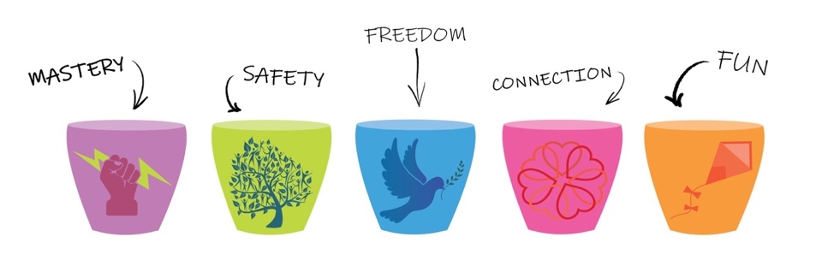

When a Specific Incident Occurs
When an incident occurs, your response as an educator is paramount for creating an environment of mutual respect - an environment where we look after the people, animals, plants and resources. These respectful “teachable moments” can be adapted to any age group and for children with individual/additional needs and link with our Philosophy/ Acknowledgement of Country.

Educator Strategy | Example
Never ignore a behaviour that needs addressing. | This means a behaviour that is causing “harm”. Note: If no-one is getting hurt/in danger of getting hurt, it is healthy for children to release feelings & practise resolving conflict.
If unsure ask for help. | Talk to a more experienced educator
Be reflective/responsive. Why is the behaviour is happening? (refer to: Phoenix cups). | Consider the child’s age/developmental stage/abilities, environmental factors, temperament, supervision levels, transitions underway, resources available.
Never use time-out/anger/shaming/ lecturing to communicate with children. Instead, encourage empathy and understanding. | Acknowledging hurt feelings and the consequences of the child’s action is a much better approach than “time out”. Even young children can learn that their actions have made someone sad/frustrated (use of emotional literacy). Building empathy will lead to the child feeling responsible for their actions and in their own time and way, will be able to offer an apology.
Try to distract/diffuse a situation and provide choices to develop agency. | A child does not want to sit down, you could say “Who would you like to sit next to?”
Use a calm manner to indicate expectations – offer a choice where possible. | “You can stay in the sandpit and play safely, or you can ride a bike.”
If harmful behaviour is not caught in time, calmly remind the child of the limits. | “You want that toy, but it is not OK to hit” or model “Can I please have a turn?”
Positively guide situations. | Use the “Say what you see, ask the question” method, giving them an “out”. “I can see you want to throw sand. That might hurt. Can I show you balls to throw safely?”
Use positive guiding sentences | Instead of “Stop running”, say “Stop please. We need to walk inside.” A “Stop” hand signal visualises the message.
Use respectful language, explaining why the behaviour was not helpful, encouraging empathy and understanding. | “It’s OK to run outside. Inside there are games on the floor inside and you could trip and hurt someone.”
Be clear about consequences of harmful behaviour. Follow through with consequences. | Consequences may be to clean up or take self-regulation time away from play to calm down with an educator.
If a child may hurt themselves or others (hitting, throwing toys, climbing fence), consider re-directing the child from the area. (A last resort). | Calmly and gently move the child away, allowing them space to calm down (self-regulation time). Stay with the child and let them know what was “not OK”. Allow them to come up with their own alternatives and reassure them you are there to help if they need it.
Help the child back into play. | Ask the child what activity they’d like to return to.
If a child is extremely distressed, consider gently holding the child close. | This is only appropriate if the child is very distressed and the child and educator are not in danger of injury.
Restore a positive relationship with the child. | Later in the day, comment on a positive behaviour. For every 1 negative, try to do 5 positives.

Supervision of Children
All educators must position themselves so they can see and hear all areas available to the children in their care and be actively supervising and engaging with the children at all times. Refer to: Supervision and Water Safety Policy. It is not acceptable to be sitting, having a personal conversation with another educator. Please keep personal conversations to your own time.

Lack of adequate supervision leads to:
- Accidents and injuries
- A breach of Heritage’s licensing requirements
- A breach of your duty of care and your job description
- Unsettled parents who lose confidence in the service

AT NO TIME WILL ANY CHILD BE LEFT UNSUPERVISED

Professional Relationships

Honesty and Integrity
The quality of education and care given to children and families enrolled at Heritage depends on each educator’s integrity and honesty. Please see honesty as part of your duty in your working relationships. Relief educators are in a position of trust and while educating and caring for other people’s children, must speak the truth to others and the Director.

ALWAYS BE HONEST, COURTEOUS AND PLEASANT

Confidentiality
As you are working in close contact with young children you are in a position to learn personal facts about them and their families. Your position of responsibility as an early childhood education and care professional requires that you treat this sort of information as confidential.
If you feel there is a particular problem or issue concerning a child, please see your Room Leader or Director so they may handle the situation. It is the responsibility of the Heritage Director and Room Leaders to discuss such issues with families according to the Heritage Policies and Procedures. No employee may solicit, encourage or act in such a way that suggests families remove their children from Heritage.

KEEP ALL INFORMATION ABOUT HERITAGE
CHILDREN AND FAMILIES CONFIDENTIAL

Authorisations
No relief educator may speak or write on behalf of Heritage Early Childhood Centre without prior approval in writing from the Heritage Director or Room Leader. All correspondence, information to families shall be checked by the Room Leader or signed by the Director before it is given out., including incident and accident forms.

Staff Relationships
It is important that all staff relationships are of the highest integrity so educators and management can operate under the best possible conditions. Where this is not the case, the consequences can be very distressing. It only takes one relief educator to cause a disruptive atmosphere throughout the whole service by their negative mood or poor work performance, which in turn distresses the children. Heritage expects all educators to be respectful, open and cheerful towards each other, completing their tasks with speed and accuracy.

The Heritage Director is to be made aware of any educator relationship problems so they can then be handled in a professional manner according to the Heritage Policies and Procedures.

Possible disruptive actions include:
- Unfinished or slap-dash duties - causing an extra burden on other educators
- Unprofessional behaviour guidance of the children - please do not intervene if another educator is supporting a child. If you are concerned, discuss with the Room Leader/Director
- Allowing private problems to encroach into the workplace - children soon pick up
an unhappy mood and react accordingly. Other educators feel threatened by moodiness, as it is difficult to determine the cause. Please leave personal problems at home.
- Adverse comments or innuendo about other educators and innuendo make for very poor staff relations. If you can't say it to a person's face or don’t have anything nice to say, don't say it at all.
- Talking about politics, religion or human rights issues – such issues are personal, subjective and create strong emotions which can make other educators and families feel uncomfortable, lead to conflict or distract educators from doing their job. Heritage is a very culturally and linguistically diverse community, and such discussions are best left to when away from the premises.

It is expected that Heritage will not be used as a political, religious or human rights platform and that while in Heritage uniform, educators will not discuss such issues.

Relationships with Families
This is a sensitive area and requires professionalism, integrity and discretion by all our educators. There are many difficult situations which may arise when talking with families and it is required that ALL conversations which refer to a child’s problems or behaviour must be conducted in the presence of the Room Leader or Heritage Director and according to the Heritage Policies and Procedures.

Please ensure that you establish a good relationship with each child's family and be polite at all times. Keep conversations brief as your attention should only be taken away from the children in your care for a minimum amount of time so that supervision and therefore the level of safety, education and care given to the children, remains of the highest quality.

Relationships with Visitors
Relief educators must always respect visitors who come through the premises. If they are not accompanied by the Director, ALWAYS refer them to the Responsible Person in Charge as indicated on the Office Door so that they may sign the visitor’s book. Please direct families who enquire about paying fees to the Heritage Director or Nominated Supervisor in the Office.

Please remember, some visitors come in an inspectorate role from the ACT government. They will be looking to see how well you accomplish your task of educating and caring for the children. If it occurs, please relax and keep performing your normal high standard of work. Please keep in mind this may affect our Quality Rating.

ALWAYS BE POLITE TO VISITORS AND REFER THEM TO HERITAGE DIRECTOR

Social Media
Members of the Heritage community including educators and families must abide by our social media guidelines and are not permitted to upload posts that relating to other members of the Heritage community that:
- Are abusive, bullying, harassing, defaming or give offence
- Contain personal and/or cultural attacks or insults
- Are potentially libellous or defamatory

Our educators are asked not to become friends with parents on Facebook as it becomes hard to maintain a professional role.

Personal Telephone Calls
- Your mobile phone must be turned off and stored in your locker during working hours. You are welcome to check and use your mobile phone during your breaks or in an emergency. Families may call the Heritage Office (02 6249 8851) in an emergency and we will immediately pass on the message to staff.
- We are proud of the many world cultures represented at Heritage, however we do ask that all staff speak English while using their phone in the presence of others as they may feel uncomfortable if they cannot understand the language being spoken.
- Please leave the staff room when making/receiving a personal phone call.

Health and Safety
Accidents, Illness and Emergencies
Heritage has a duty of care to ensure that no employee or child on the premises is exposed to unnecessary hazards. Procedures are in place for reducing risks and dealing with accidents, injury, illness, trauma and other emergencies. Refer to: Procedure posters in rooms; Policy Handbook and Manuals; the Heritage Floor Plan attached.

Smoking, Drugs and Alcohol
Smoking, Illegal drugs and alcohol are NOT permitted on the Heritage premises. Failure to comply will, depending on circumstances, lead to dismissal. The reasons are:
- It is a legal requirement that smoking, drugs and alcohol are not present in an early
childhood education and care environment
- All dangerous substances are a risk to the wellbeing of the children
- They are all health hazards for the consumer as well as those around them
- Being under the "influence" of alcohol or drugs leads to inadequate attention being paid to the wellbeing of the children
- They are offensive to other educators, children and the entire Heritage community
- Smoking may increase the risk of asthma attacks and breathing difficulties in
members of the Heritage community
- Note: Relief educators who require prescription medication must ensure their use does not adversely affects their capacity to provide education and care to children, and they are safely stored and inaccessible to children.

Standards of Dress
- Heritage polo shirts/tops are available for regular relief educators to wear.
- All clothing worn at Heritage must be non-provocative - no revealing tops/skimpy shorts/ skirts, sun dresses without straps, active gym wear or other clothing unsuitable for work.
- Clothing shall not be so short as to prohibit a relief educator from bending over to assist a child or move equipment.
- Good grooming shall always be in evidence - hair well cut and clean, long hair tied back.
Footwear
Footwear shall be functional and not likely to cause accidents. Thongs, slippers, Ugg boots, crocs, very high heels or bare feet are not acceptable and are unprofessional.

Personal Hygiene
- For the comfort of the whole Heritage community, please see that your own personal hygiene is of the highest standard, ie, daily shower/bath, brush teeth, clean hair, clean clothes and use deodorant.
- Please be mindful that over-use of deodorants and perfumes can course headaches and discomfort to other people.
Handwashing
Posters are placed near all sinks to illustrate the procedures for hand washing to educators and children. Educators must wash their hands or use alcohol-based hand rub:
- On arrival at and departure from Heritage
- Before and after handling food, including before feeding an infant a bottle
- After handling animals
- Before and after first aid procedures, including when giving medication
- Before wearing disposable gloves
- After toileting or nappy changing
- After handling or cleaning up bodily fluids such as blood, faeces and vomit
- After handling chemicals or garbage bags
- After handling animals or animal food
- After washing soiled clothing
- After nose wiping, sneezing, coughing or touching a disposable tissue
- After biting nails or touching a sore/pimple
Children must wash hands or have their hands washed:
- After going to the toilet
- After wiping their own nose
- Before and after handling food or eating
- After handling animals
- As required if hands appear excessively dirty such as from sandpit or after art and craft
- After playing outside
Babies who cannot stand at a basin must have their hands washed with a single use wipe or disposable towelette and dried with a single use paper towel.

UV/Sun Protection
Heritage is a SunSmart Accredited service and our educators have a duty of care regarding occupational Ultra-violet Radiation (UVR) exposure and are required to act as role models for the children by demonstrating sun-safe behaviour.
You must:
- Wear a SunSmart hat and clothing when outdoors. This means:
  - A bucket hat with a deep crown and brim size of at least 6cm or a broad brimmed hat with a brim size of at least 7.5cm.
  - A Heritage polo shirt or dress with collar or high neck and sleeves; trousers, longer shorts or skirts made from closely woven material.
- Apply SPF30+ broad-spectrum, water resistant, sunscreen, before going outdoors, (where practicable, 15-20 minutes before sun exposure) except during June and July, unless you have an allergy to sunscreen, in which case you must wear long sleeved shirt and pants.
  - Educators with naturally very dark skin may opt not to wear sunscreen - however hats and sunglasses should still be worn (Wrap-around sunglasses to meet Australian Standard 1067, are close fitting and are preferably marked Eye Protection Factor (EPF) 10 are recommended.

Complaints, Grievances and Non-Compliance Policies
- When a member of the Heritage community, be it a child, educator, parent or visitor, has a grievance against or a disagreement regarding a policy or procedure with another member of the Heritage community, the guidelines for the course of action to be undertaken can be found in the Complaints and Grievance Management Policy or the Staff Complaints and Grievance Management Policy located in the Policy and Procedures Folders in the Programming Room and Director’s office.
- If, after due process, the Director or Management Committee or other nominated party deems that a person in the Heritage community has not complied with Heritage policies or procedures, the Non-Compliance Policy & Procedures will be applied as appropriate.

Child Protection Policy
Initially it is preferred, though not compulsory, that educators inform the Director if they suspect child abuse/neglect. If there is an issue between an educator and the Director, and the educator has reasonable grounds to suspect that a child is at risk of harm, the educator is legally required to report directly to:
- Care and Protection Services Centralised Intake Service:
  - Mandated Persons Line (24 hrs): 1300 556 728 9
  - Email address: childprotection@act.gov.au
- Police (if life threatening situation) on 0-000 (internal line) or 000 (external line)

AS FAR AS PRACTICABLE, NO EDUCATOR IS TO BE LEFT ALONE WITH A CHILD
Back Deck
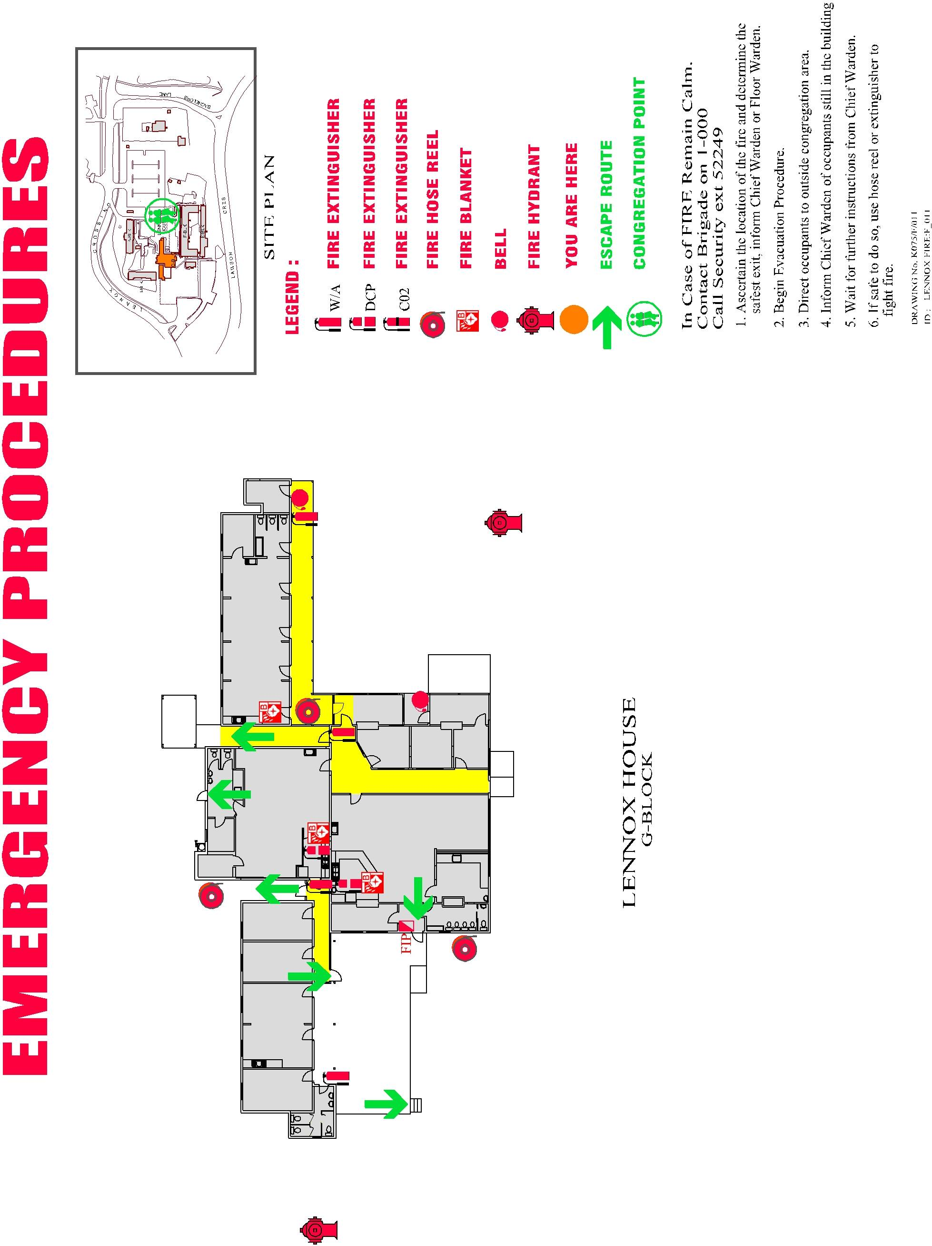
Toddler Room
Back Deck
Staff Room and Cot Rooms
Nursery

Preschool Room
Summary of COVID-!9 Policy and Procedures (as at May 2022)
Heritage keeps up to date with and follows the advice of The ACT Health Directorate and Education Directorate (CECA) for managing the spread of COVID-19, in line with the latest national health advice.
- Managing a Confirmed Case in ECEC
- COVID-19 Health Information Line: Ph:1800 020 080 Interpreting Service: Ph:131 450
What are the symptoms?
- Symptoms include fever, cough, sore throat, fatigue and shortness of breath. Other symptoms can include runny nose, chills, body aches and headache, loss of taste/smell, conjunctivitis, unexplained chest pain. Refer to: Health Direct Symptom Checker
Attendance Records
- Attendance records will be maintained for all children, parents, staff, students, volunteers and visitors, including a contact phone number for the day.
- All visitors to the premises must sign the Visitors Book using their own pen or a sanitised pen provided by Heritage.
Heritage Risk Management Strategy
- The Director will regularly check relevant authorities for current information and update the Illness and Infectious Diseases policy and related policies as necessary as the situation develops/changes.
- Heritage will identify and manage the risks of the virus entering and spreading at the service with appropriate control measures and by rapidly applying any Government mandates and guidelines.
- All contact staff will be required to be double COVID -19 vaccinated as part of their Terms of Employment, and strongly encouraged to have their COVID-19 booster and annual influenza jab.
- Families will be strongly encouraged to follow COVID Smart Behaviours and be vaccinated against influenza and COVID-19 in line with ACT Health advice.
- All staff and visitors will be required to wear a mask while inside the premises, unless eating or drinking or where it limits effective communication and the provision of quality education and care.
- Rapid Antigen Tests will be provided as needed for contact staff.
- Practicing good hand hygiene is understood to be the best defence against the germs that cause respiratory infections, as well as avoiding close contact with others (physical distancing), regular environmental cleaning and good ventilation.
- Heritage educators and children will be reminded to strictly follow the Hygiene and Infection Control Policy and wash hands thoroughly and often for 20 seconds, (or use alcohol-based sanitiser if hand washing is not available) throughout the day.
- Environmental cleaning will be increased including more frequent cleaning and sanitising of high-touch surfaces during the pandemic (Regular COVID-safe cleaning). This will be further enhanced when a positive or suspected case arises at the service in line with ICEG COVID cleaning and disinfection guidelines. Note: Deep cleaning, requiring the service to close for up to two days, will only be conducted by a specialist service on a case-by-case basis on advice from CECA/ACT Health.
- Heritage educators and children will be reminded to cough and sneeze into their elbow or directly into a tissue and throw the tissue in a bin, to avoid touching their eyes, nose and mouth with unwashed hands and to avoid close contact with others.
- Heritage will consider physical distancing strategies during heightened risk periods, taking into account the advice of The Australian Health Protection Principle Committee (AHPCC) that maintaining 1.5m between children is not appropriate or practical in education and care services. The advice applies to children interacting with other children, and also to adults providing care or interacting with children in this environment.
- Adults must continue to undertake physical distancing when interacting with other adults, in areas such as staff rooms and when picking up or dropping off children.
- Parents will be encouraged not to come into the service during heightened risk periods and arrival and departure routines modified to encourage physical distancing and reduce contact with families/carers at pick up and drop off as far as practicable.
- Educators will consider the setup of rooms and implement small group play, staggered mealtimes and outdoor play opportunities whenever possible.
- Windows will be opened during the day where possible, ventilation maximised, and air purifiers placed in each room.
- Educators will mitigate the risks of activities that may spread germs eg, sharing play dough. using wind instruments (eg, regularly replacing play dough, singing outside).
- Food sharing will be avoided.
- Social events, meetings, visitors and excursions will be restricted during heightened risk periods and risk assessments conducted that take into account the latest advice from the authorities and those at high risk such as those with medical conditions.
- Training will be provided to support educators such as through the provision of resources/webinars.
- The Director will provide information/factsheets to families and staff on the virus and to support mental health and wellbeing. Refer to: Members Area of the Heritage Website.

Exclusion Requirements
- Those who have returned from interstate or overseas until they have completed any current restrictions.
- Children who are household contacts of a person diagnosed with COVID-19, until that person has completed their quarantine period.
- Those who have been diagnosed with COVID-19 or have a fever or other COVID-19 symptoms until they have completed the current testing and isolation/quarantine requirements and their symptoms resolve.
- Note 2: Children will not be excluded if they have a letter from their G.P. regarding an on-going, non-infectious, medical condition explaining the symptoms. However, they will be observed for new symptoms.
- Note 2: If a child has COVID-19 symptoms but tests negative on a RAT, they should have a PCR test and stay at home until the result. If the PCR is positive, they should follow the current guidance for people with COVID -19. If the PCR test is negative, they may return to Heritage when they are well.
- As per this policy, any child or staff member who is unwell and reasonably suspected to have a communicable disease will be excluded until cleared by a doctor to return.

Procedures for a Positive Case
- Where a staff member/child/visitor is diagnosed with COVID-19 and may have attended Heritage during their infectious period (2 days before they started having symptoms or tested positive - whichever came first), they or their parent must notify the service asap.
- Where a staff member/child/visitor is exposed to a confirmed case through a household contact, they or their parent/carer must notify the service as soon as possible.
The Director/Nominated Supervisor will:
- Follow the Step By Step process provided by CECA in the current operational guidance.
- Record the date of the positive test for the child, staff member or visitor and confirm whether they attended Heritage during their infectious period. The infectious period is two days before someone started having symptoms or tested positive (whichever came first). If the person was not at the service during their infectious period, no assessment is required.
- Identify date(s) and locations (eg room, office, other) of potential exposure.
- Inform the relevant cohort that there has been a potential exposure on relevant date(s).
- Provide information on monitoring for symptoms, recommend COVID-19 testing and advise them not to attend if they have symptoms.
- Ensure enhanced COVID-safe cleaning is undertaken in line with the Infection Control Expert Group (ICEG) COVID cleaning and disinfection guidelines.

Actions for Staff and Visitors Exposed to COVID-19
- Staff who have had a COVID-19 exposure, such as a household exposure, do not have symptoms and return a negative COVID-19 test result (RAT or PCR) can continue to attend the service.
- They must take a test immediately if any COVID-19 symptoms develop, no matter how mild, and isolate until a negative result is received and symptoms resolve.

Procedures for Sick Children at the Service
- Where a child presents with COVID-19 symptoms while at the service, educators must ensure the child’s family is contacted immediately, and they are asked to collect them as soon as possible, and to test and quarantine in line with current requirements and seek medical advice if concerned.
- Ensure the child is cared for in an area that has been identified as appropriate to isolate staff/children who may become sick with COVID-19 ie, is separate from others and allows for appropriate supervision.
- Ensure the child is supervised by a staff member wearing a mask. Note: Supervising staff member does not need to isolate unless they have symptoms or the child is confirmed to have COVID-19.
- If the child tests negative on a RAT, advising the family to take another RAT in 24 hours or have a PCR test to exclude COVID-19 and to remain at home until the negative result is received and their symptoms resolve. Note: PCR tests are preferred for children under 2.

Procedures for Sick Staff and Visitors/Volunteers at the Service
- Ensure visitors or staff with symptoms are asked to stop work and sent home immediately and advised to travel directly home and to wear a mask on the journey.
- Ensure sick staff and volunteers isolate in an appropriate space away from others, sanitise their hands and wear a mask while waiting to return home.
- Ensure the staff member/visitor/volunteer is advised to test and quarantine in line with current guidelines and to seek medical advice if symptoms are concerning.
- If the person tests negative on a RAT, advising them to take another RAT in 24 hours or have a PCR test to exclude COVID-19 and to remain at home until a negative result is received and symptoms resolve. Note: Where staff or visitors have other medical reasons for recurrent symptoms that are similar to COVID-19, a letter from the GP is sufficient to allow return to Heritage without returning a negative COVID test. However, they must be carefully monitored for new symptoms.
The Heritage Early Childhood Centre Privacy Statement
Heritage recognises its responsibility to uphold the Australian Privacy Principles and Education and Care National Law and Regulations 2011, including Regulation 181 – Confidentiality of Records, and takes the privacy of its staff, families and enrolled children seriously. Our Privacy and Confidentiality Policy, details how we collect, hold, use, disclose and provide access to personal information, including health information. We take all practicable steps to ensure that the details we retain about our families and educators are accurate, up to date and held securely. If we collect health information, our procedures are subject to the Health Records (Privacy and Access) Act 1997.

The reasons for which we collect personal information:
- Meet our legal obligations.
- Allow us to carry out our duty of care including health and safety considerations.
- Provide the best possible education and care for each enrolled child.
- Ensure the welfare of educators and all other staff and supervised students.
- Manage the service and meet its’ obligations under the service Constitution.
- Meet insurance requirements.
- Facilitate day-to-day administration and delivery of the service.
- Correspond with parents/guardians relating to their child’s day to day activities.
- For use in emergencies.
- Gain payments from Government agencies such as Child Care Subsidy.
- Enable communication between the Committee, employees and enrolled families.
- Assess job applicants, contractors, employees, volunteers or students and administer their employment, contracts or placements.
- Continuously monitor the quality of the service.
- Create newsletters, displays in rooms and promotional material including on our website.

Some personal/health information held about an individual may be disclosed to:
- Government departments or agencies, as part of our legal and funding obligations.
- Local government authorities, for planning purposes.
- Organisations providing services related to employee entitlements and employment.
- Insurance providers, in relation to specific claims or for obtaining cover.
- Law enforcement agencies.
- Health organisations and/or families in circumstances where the person requires urgent medical assistance and is incapable of giving permission.
- Anyone to whom the individual authorises us to disclose information.

Laws that require us to collect specific information
The Education and Care Services National Law Act 2010 and the Education and Care Services National Regulations 2011, Associations Incorporation Act 1991 (ACT) and employment-related laws and agreements require us to collect specific information about individuals. Failure to provide the required information could affect a child’s enrolment at the service, a person’s employment with the service or the ability to function as an Incorporated Association.

Access to information
- Individuals about whom we hold personal information, including health information, are able to access this information promptly in accordance with applicable legislation.
- Any member of the Heritage community may seek access to view or update their own or their child’s personal or health information at any time contacting the Director (or the Secretary of the Management Committee).

Complaints Procedure
- Individuals may make a complaint to the Director if they believe there has been a breach of their privacy. The breach will be assessed within 14 days. Where the information collected is incorrect, the information will be corrected. Where a serious breach of privacy is found, appropriate actions will be negotiated with the individual to resolve the situation, in line with the Complaints and Grievance Management Policy.
- If individuals are not satisfied with the response, they are able to lodge a complaint with the Office of the Australian Information Commissioner.
Heritage Code of Conduct/Ethics
On joining the Heritage community, educators agree to act according to the principles below:

Heritage Code of Conduct Core Principles
- Each child has unique interests and strengths and the capacity to contribute to their communities.
- Children are citizens from birth with civil, cultural, linguistic, social and economic rights.
- Effective learning and teaching is characterised by professional decisions that draw on specialised knowledge and multiple perspectives.
- Partnerships with families and communities support shared responsibility for children’s learning, development and wellbeing.
- Democratic, fair and inclusive practices promote equity and a strong sense of belonging.
- Respectful, responsive and reciprocal relationships are central to children’s education and care.
- Play and leisure are essential for children’s learning, development and wellbeing.
- Research, inquiry and practice-based evidence inform quality education and care.

In relation to children, I will:
- Act in the best interests of all children and create and maintain safe, healthy, inclusive environments that support children’s agency and enhance their learning.
- Provide a meaningful curriculum to enrich children’s learning, balancing child and educator-initiated experiences.
- Understand and be able to explain to others how play and leisure enhance children’s learning, development and wellbeing.
- Ensure childhood is a time for being in the here and now and not solely about preparation for the future.
- Collaborate with children as global citizens in learning about our shared responsibilities to the environment and humanity.
- Value the relationship between children and their families and enhance these relationships through my practice.
- Ensure that children are not discriminated against on the basis of gender, sexuality, age, ability, economic status, family structure, lifestyle, ethnicity, religion, language, culture, or national origin.
- Negotiate children’s participation in research, by taking into account their safety, privacy, levels of fatigue and interest.
- Respect children as capable learners by including their perspectives in teaching, learning and assessment.
- Safeguard the security of information and documentation about children, particularly when shared on digital platforms.

In relation to families, I will:
- Support families as children’s first and most important teacher and respect their right to make decisions about their children.
- Listen to and learn with families and engage in shared decision making, planning and assessment practices in relation to children’s learning, development and wellbeing.
- Develop respectful relationships based on open communication with the aim of encouraging families’ engagement and to build a strong sense of belonging.
- Learn about, respect and respond to the uniqueness of each family, their circumstances, culture, family structure, customs, language, beliefs and kinship systems.
- Respect families’ right to privacy and maintain confidentiality.
In relation to colleagues, I will:
- Encourage others to adopt and act in accordance with this Code and take action in the presence of unethical behaviours.
- Build a spirit of collegiality and professionalism through collaborative relationships based on trust, respect and honesty.
- Acknowledge and support the diverse strengths and experiences of colleagues in order to build shared professional knowledge, understanding and skills.
- Use constructive processes to address differences of opinion in order to negotiate shared perspectives and actions.
- Participate in a ‘lively culture of professional inquiry’ to support continuous improvement.
- Implement strategies that support and mentor colleagues to make positive contributions to the profession.
- Maintain ethical relationships in my online interactions.
In relation to communities, community and society I will:
- Learn about local community contexts and aspirations in order to create responsive programs to enhance children’s learning, development and wellbeing.
- Collaborate with people, services and agencies to develop shared understandings and actions that support children and families.
- Use research and practice-based evidence to advocate for a society where all children have access to quality education and care.
- Promote the value of children’s contribution as citizens to the development of strong communities.
- Work to promote increased appreciation of the importance of childhood including how children learn and develop, in order to inform programs and systems of assessment that benefit children.
- Advocate for the development and implementation of laws and policies that promote the rights and best interests of children and families.
In relation to the profession, I will:
- Base my work on research, theories, content knowledge, practice evidence and my understanding of the children and families with whom I work.
- Take responsibility for articulating my professional values, knowledge and practice and the positive contribution our profession makes to society.
- Engage in critical reflection, ongoing professional learning and support research that builds my knowledge and that of the profession.
- Work within the scope of my professional role and avoid misrepresentation of my professional competence and qualifications.
- Encourage qualities and practices of ethical leadership within the profession.
- Model quality practice and provide constructive feedback and assessment for students as aspiring professional.
- Mentor new graduates by supporting their induction into the profession.
- Advocate for my profession and the provision of quality education and care.

Acknowledgement of Heritage Code of Conduct (Ethics)

I _______________________________________ have read and fully understand the Code of Conduct (Ethics) for Heritage Early Childhood Centre, as outlined in the Relief Educator Handbook.

Signed ___________________________________Date ___/___/______

Agreement of Terms

I _______________________________________ have read and fully understand the requirements of my employment at Heritage Early Childhood Centre as outlined in the Relief Educator Handbook.

By signing this agreement, I am stating that I understand the roles and responsibilities of a relief educator employed by Heritage Early Childhood Centre.

Signed ___________________________________Date ___/___/______

This acknowledgement will be photocopied and kept on your employment record in the office.

